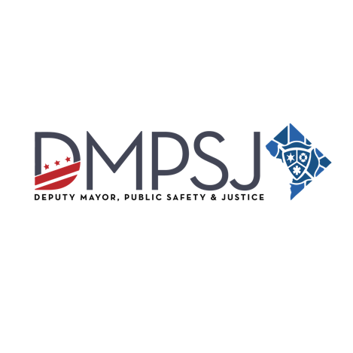
PRESS RELEASE

FOR IMMEDIATE RELEASE:
June 26, 2023

CONTACT:
Isaiah Cromer (DMPSJ) – (202) 374-6873; isaiah.cromer@dc.gov

Bowser Administration Issues FY24 Safe Passage, Safe Blocks Request for Application
Popular program enhances safety for students traveling to and from school, helps reduce incidents of violence in identified priority communities

(WASHINGTON, DC) – A request for application (RFA) for the District of Columbia’s Safe Passage, Safe Blocks Program has been released for Fiscal Year (FY) 2024.

Starting October 1, 2023, the Office of the Deputy Mayor of Public Safety and Justice (DMPSJ) will assume management, oversight, and evaluation of the popular District program known as “Safe Passage”. Safe Passage Ambassadors, donning their recognizable green vests, are stationed along select routes to enhance student safety as they travel to and from school.

DMPSJ seeks to partner with qualified organizations that can provide student monitoring, high-impact engagement, and violence intervention services to select schools within eight priority neighborhoods: Anacostia/Good Hope Road, Columbia Heights, Congress Heights, L’Enfant Plaza and Waterfront; Minnesota Avenue, NoMa-Gallaudet U, Petworth/Brightwood, and Tenleytown. The RFA is available here and applications are open until July 12, 2023.

New for the 2023-2024 academic year, each grantee will be required to employ a roving team of Safe Passage personnel charged with providing intervention supports to address active conflict or violence. The roving team members must be highly skilled and able to work in communities throughout the District, and travel to schools, priority commute routes, or events as needed.

“We firmly believe that one of the most critical actions we can take to advance the long-term safety, wellbeing and thriving for our young people is to ensure that they are in school and helping them to arrive safely is a key part of making that happen. " said Deputy Mayor for Public Safety and Justice Lindsey Appiah. “The transfer of Safe Passage to our office ensures a cohesive, coordinated continuum of prevention services and supports for that exist in our public safety ecosystem.”

Safe Passage utilizes a community-based crime reduction model to improve student safety in Safe Blocks priority areas through surveillance and violence interruption services. The program’s core required implementation components include:
- Monitoring of student commute routes within the assigned Safe Blocks priority areas.
- Working collaboratively with schools, relevant District agency staff, other Safe Passage teams, and the surrounding community to identify, intervene, diffuse, and report community violence.
- Supporting attendance by encouraging students to attend class daily and on time.
- Positively engaging with students, families, businesses, civic associations, institutional facilities, and community members within the priority area to build support for the Safe Passage program.
- Developing and maintaining networks of neighborhood contacts and relationships to enable detection of potentially violent conflicts so that program staff may intervene to de-escalate and mediate to prevent violence.
- Ensuring staff suitability and participation in all training and technical assistance.
- Collecting and analyzing program data to identify trends and ensure proper program implementation.

DMPSJ is working closely with the Deputy Mayor for Education and the Office of Victim Services and Grants in the transition of the program to ensure no service disruptions for students. Training of the Safe Passage Ambassadors and grantee staff will be held later this summer.

Born out of the School Safety and Safe Passage Working Group during the 2017-18 school year, the Safe Passage, Safe Blocks Program places trusted adults along specific routes to help ensure that students get to and from school safely. The Working Group collaborated with a variety of stakeholders including local District education agencies, Office of Neighborhood Safety and Engagement, Metropolitan Police Department, Department of Transportation, Metro Transit Police Department, and Washington Metropolitan Area Transit Authority to identify areas that need additional support based on the number of student-involved incidents reported and anecdotal insights from the Working Group.

###

Social Media:
